**Lesson Notes**

1. What is the main purpose of an Operating System?
2. What is the difference between Operating System Software and Use Application Software?
3. What is the difference between Operating System Software and Computer Hardware?
4. What are the main parts of an Operating System?
5. What are some popular operating systems?

**Reference Diagram**

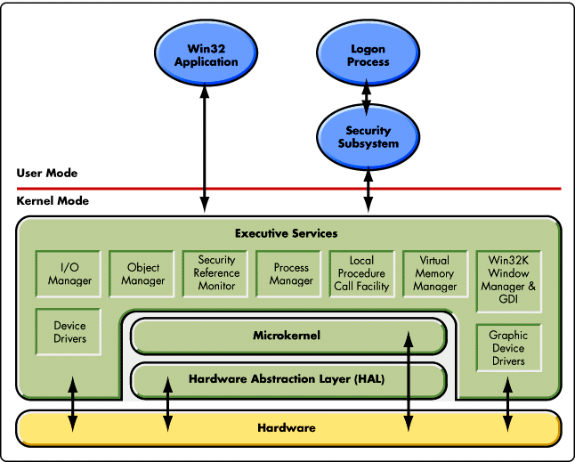 operating system components

DLL

Local Device printer Graphics card

**Student Questions**

1. What is a device driver?
   1. Provide a brief summary

A gadget driver is a document that tells the PC the arrangement and details of a specific equipment gadget. A few instances of gadgets that need drivers are hard drives, DVD drives, and PCI cards.

* 1. List some devices that require a device driver.

Hard drivers, DVD drivers, and PCI cards.

* 1. Provide a label on the reference diagram for the location of a device driver for your graphics card.
  2. Provide a label on the reference diagram for the location of a device driver for a locally attached printer.

1. What is a DLL?
   1. Provide a brief summary

A DLL file, short for Dynamic Link Library, is a type of file that contains instructions that other programs can call upon to do certain things.

* 1. Explain how DLLs are related to user application programs

DLL files are dynamically linked with the program that uses them during program execution rather than being compiled into the main program.

* 1. Provide a label on the reference diagram for the location of a DLL

1. What is a windows manager?
   1. Provide a brief summary

A window administrator is a framework programming that controls the arrangement and presence of windows inside a windowing framework in a graphical UI

* 1. Explain how a windows manager is related to user application programs

Because the user applications are in or located in the windows manager.

1. What is the windows task manager?
   1. Provide a brief summary

Windows Task Manager, is a task manager, system monitor, and startup manager included with Microsoft Windows systems.

* 1. List and explain four (4) types of system information provided by the task manager

Memory Manager

Process Manager

Security Monitor

Update Manager

* 1. Provide a label on the reference diagram for the operating system components related to each type of information.